

*Data Validation:*

*Purchasing*

**Table of Contents**

Data Validation 3

Why 3

Roles & Responsibilities 3

Vendors 4

Why 4

What to check 4

How 6

Roles & Responsibilities 6

Purchase Orders 7

Why 7

What to check 7

How 15

Roles & Responsibilities 15

Data Validation – Full Circle 16

Data Imported 16

Data Validated 16

Data Processed 16

Postings 16

Reports 16

Why Data Validation Is Critical 17

Lower Risks 17

Go Live Duration 17

Customer Service 17

Procurement 17

Reporting 17

Success 17

# Data Validation

## Why

Why is data validation critical to any ERP implementation? Data is one of the most important parts of any implementation. The old saying of “Garbage In / Garbage Out” can be applied here. If we load bad or poor-quality data, the outputs of that data will be bad or have poor-quality. The more data validation that is done during implementation, the better the overall outputs will be. Taking ownership of the data begins with data validation. It will also provide a smoother transition and reduce or eliminate issues at Go Live. Data and data validation are key to a successful Go Live.

## Roles & Responsibilities

There are several roles that are involved with data validation. It’s a team effort. The Data Specialists, the Product Specialists, Subject Matter Experts (SMEs) and End Users have critical roles to play in data validation.

The Data Specialist’s role in validation is the same for every section so we will discuss here. It begins with the load file. Along with the Product Specialist (PS), they will review the file and determine where the data will reside in DEACOM. The Data Specialist’s responsibility is to confirm record counts and validate the information in the file loaded to the fields mapped in the data profile. This is the first level of data validation. The data profile will be modified to fix any issues found during this validation. However, the file may be missing key information that the data specialist does not know exists or during implementation new data is identified that is required to support a new process.

Data Specialists can also provide spreadsheets that can be used to easily filter or sort and review many records at one time. **Note: these spreadsheets are for validation only and will not be used to update every field on the spreadsheet. However, the spreadsheets can be used to update a single field.** The root cause of any data issue will be researched, and the data profiles updated so the data can be updated, and new records will come in with the proper changes and existing records will be updated.

The Product Specialist’s role in validation is to review the data loaded for every section and help discover, during Standard Operating Procedures (SOPs) validation, if we are missing any key data, while at the same time validating these processes using the imported data. This data will also be used in Mock Go Live and Conference Room Pilots (CRPs).

# Vendors

## Why

Vendors are key to sourcing the materials and services needed to make products, deliver services, and/or procure products for resale. There are many aspects to managing vendors from researching and sourcing vendors, as well as obtaining quotes with pricing, capabilities, turnaround times, and quality of work. If Vendors are not validated, purchase orders may be sent to the wrong address which results in a delay in receiving the materials or services needed. This may result in missed manufacturing deadlines and costly delays. If pricing contracts or specific vendor pricing is not validated, this can cause increased costs. Whether it’s the time it takes to resolve the invoice discrepancies or increased costs because old outdated costing was used, it is critical that all aspects of vendor management is validated.

## What to check

The best place to start checking is the basic information. For example, Name, Address, Email, Fax, Contact and Phone information. Other key fields include Terms, Payment method, default Ship via and Freight Type. Some vendors may require 1099 information; be sure to validate the vendor taxpayer ID or Social Security Number fields, 1099 box and 1099 form type fields if you plan to create 1099s from DEACOM. If the vendor has Remit To information, be sure the Remit To Name is filled in because it determines if Remit To information is used. If using any search or user defined fields specifically created for SOPs, those should also be validated. If vendors have pricing orders or part cross references, that information also needs to be checked.

Where to begin?

* Vendors with the top largest purchase volume.
* Vendors in different territories or industries.
* If you are bringing in inactive vendors for historical data, check a few of those too.
* In DEACOM, go to **Purchasing > Vendors**
* **Report Type**: Vendors
* **Display**: All (shows both active and inactive)
* Click on **View**

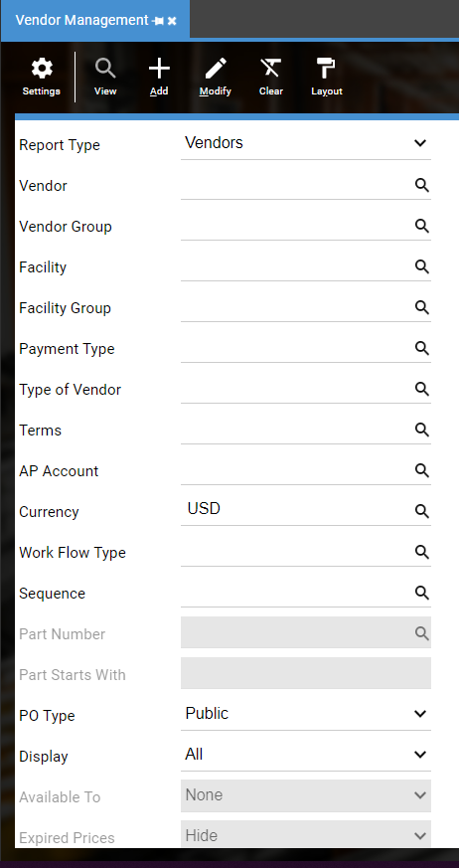

* To see your legacy Vendor ID, add ve_vendid to the grid

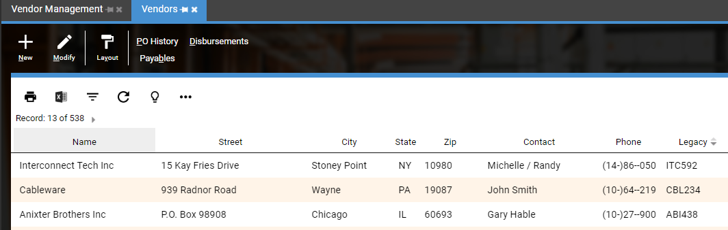

* Compare to vendors from legacy system

**General tab**

Validate Vendor, Primary contact, Address lines, Email, Fax and Phone information

Validate Soc sec # and Taxpayer ID

Validate 1099 Required checkbox

Validate Active checkbox

**Order defaults tab**

Validate Search Fields

Validate Ship Via, Freight Type and Terms

**Other**

Confirm total number of vendors match the expected number

Validate 1099 information

Validate other key fields

## How

The best way is to bring the vendor up in the legacy system and bring the vendor up in DEACOM. Carefully compare the data for each field. If you find information is missing or in the wrong field, contact the data specialist and they will determine why this is happening.

## Roles & Responsibilities

Typically, Subject Matter Experts, Purchasing and Accounting have the responsibility to validate their portion of the data. They use the data every day and can easily spot if key data is missing.

# Items

## Why

Item Master records are another key data element for a successful Go Live. The setup of these items drives how the system functions. The UOM setup is critical to how inventory is stored and recorded on purchase and sales orders.

## What to check

The best place to start checking is the basic information. For example, PO Quantity, Minimum Purchasable and Incremental PO Qty.

Where to begin?

* Highest volume supplies.
* Highest volume raw materials.
* Highest volume components.
* Highest volume sub-assemblies.
* Highest volume finished goods.
* If using MRO, check maintenance parts.
* If you are bringing in inactive items for historical formulas or orders, check a few of those too.
* In DEACOM, go to **Inventory > Item Master**
* **Report Type**: Standard
  + **Display**: All (shows both active and inactive)
  + Click on **View**

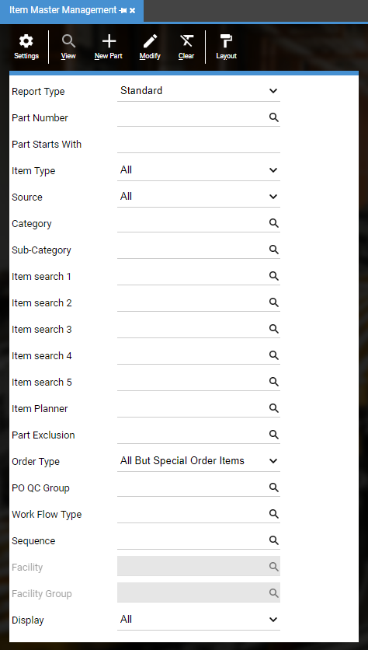

* To see your legacy Part Number, add pr_retail to the grid

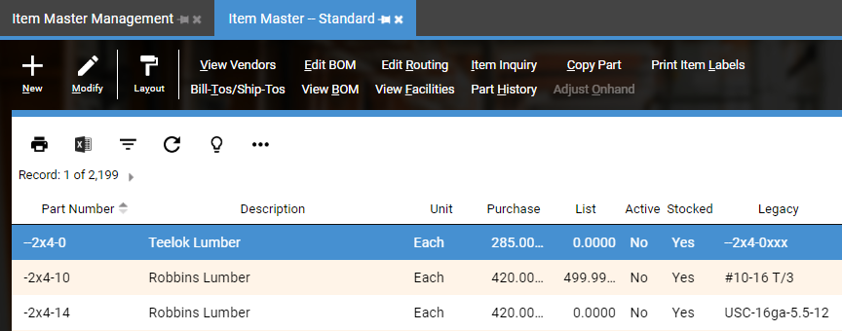

* Compare to items from legacy system

**General 2 tab**

Validate Over Issue Qty % Limit

Validate Enforce Over Issue Qty % Limit

Validate Under Issue Qty % Limit

Validate Enforce Under Issue Qty% Limit

Validate PO Recv Qty% Limit

Validate Enforce PO Overage Limit

**MRP tab**

Validate PO Quantity

Validate Min Purchasable

Validate Incremental PO Qty

Validate Lead Time

**Properties tab**

Validate Properties

**Units tab**

Validate Purchase Unit (If you find widespread problems, notify your Project Manager and Data Specialist.)

## How

The best way is to bring the item up in the legacy system and bring the item up in DEACOM. Carefully compare the data for each field. If you find information is missing or in the wrong field, contact the data specialist and they will determine why this is happening. Use the spreadsheets discussed previously to view many items at the same time. Filtering in Excel can be useful to quickly see items that are in the wrong category or inventory account.

## Roles & Responsibilities

Typically, Subject Matter Experts, Customer Service, Purchasing, Production and Accounting have the responsibility to validate their portion of the data. They use the data every day and can easily spot if key data is missing. The Accounting group would validate the account information while Production validates the MRP data (min, max, etc), and Purchasing validates PO ordering fields (PO Qty, Min. Purchasable, Incremental PO Qty, Lead times, etc.)

# Purchase Orders

## Why

Purchase Orders define the items or services to be provided by a single Vendor, along with the appropriate Payment Terms, delivery dates, item descriptions, quantities, Ship Via Methods, and all other obligations and conditions. It is vital to the ensure open purchase orders have the correct information, so deliveries of material or services continue without delay. It is also important that historical purchase orders are validated to ensure reliable reporting.

## What to check

The best place to start checking is the basic information. Confirm the legacy order number, the Vendor, AP and suspense accounts, Items, Terms, Ship via, Order Dates, Unit Price, and total order amount. Be sure to confirm 1099 information, search fields, order notes and UDFs if

applicable.

Where to begin?

* Compare open order report from legacy system to open order report from DEACOM. It is important to validate early as open orders will change after load files are prepared.
* Compare historical orders/invoices report from legacy system to historical orders/invoices report from DEACOM.
* Working from a static test copy of your legacy system is the best as the data is not changing.

You can search by your legacy system PO Number, Invoice Number or AP Reference number by entering that number into the “Text 2” field in Purchase Order Management.

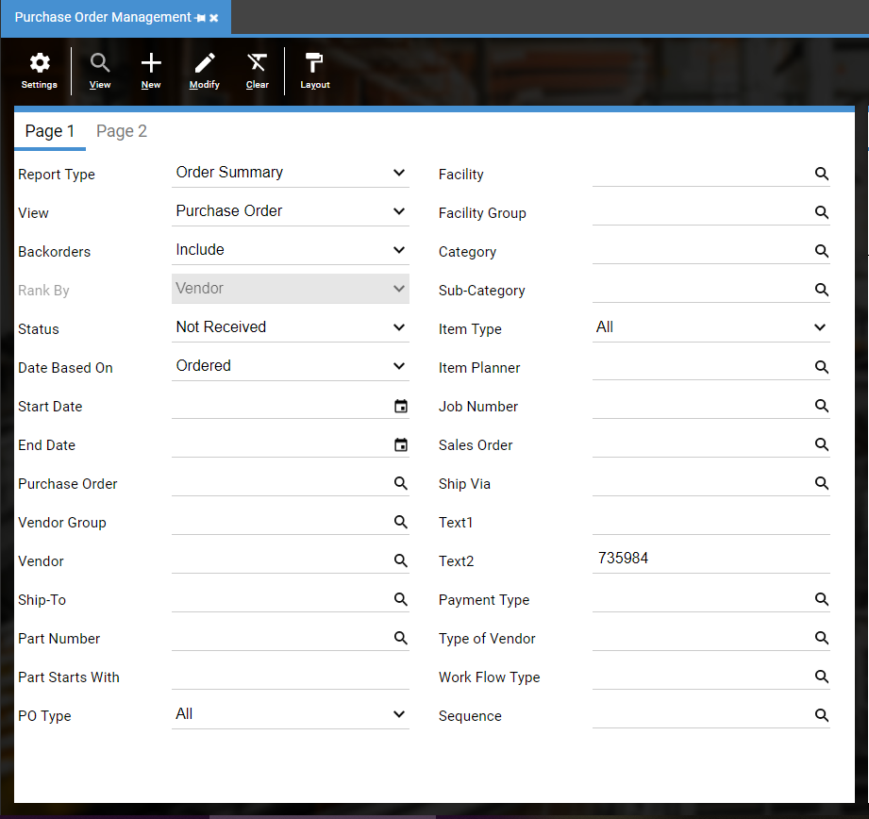

**Validation of PO - Status: Not Received**

* In DEACOM, go to **Purchasing > Order Reporting**
* **Report Type**: Order Summary
* **Status:** Not Received
* Click on **View**

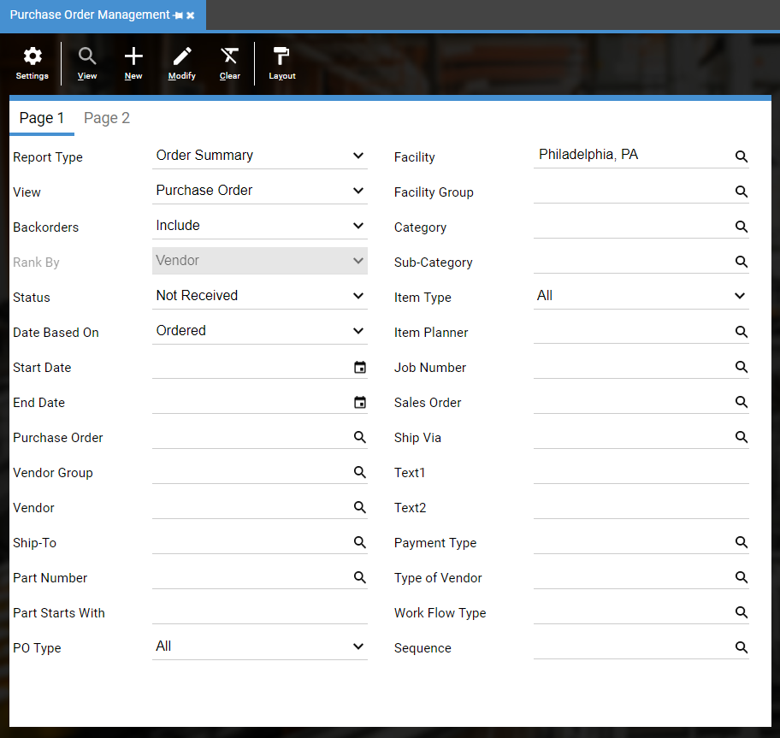

* To see your legacy Purchase Order number, add tp_ref2 to the grid

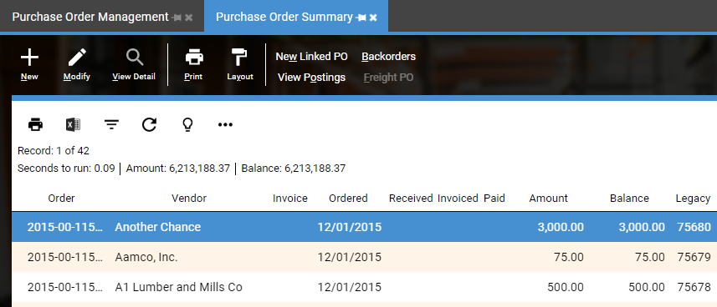

* Compare to open orders report from legacy system

Confirm total number of orders match

Confirm total Amount and Balance match

Confirm individual orders lines for accuracy

* Prior to Actual Go Live, test daily processes using imported data. This typically occurs after a Mock Go Live and/or during a Conference Room Pilot (CRP).

Receive open Purchase Orders

**Validation of PO – Status: Rec Not Invoiced**

* In DEACOM, go to **Purchasing > Order Reporting**
* **Report Type**: Order Summary
* **Status**: Received Not Invoiced
* Click on **View**

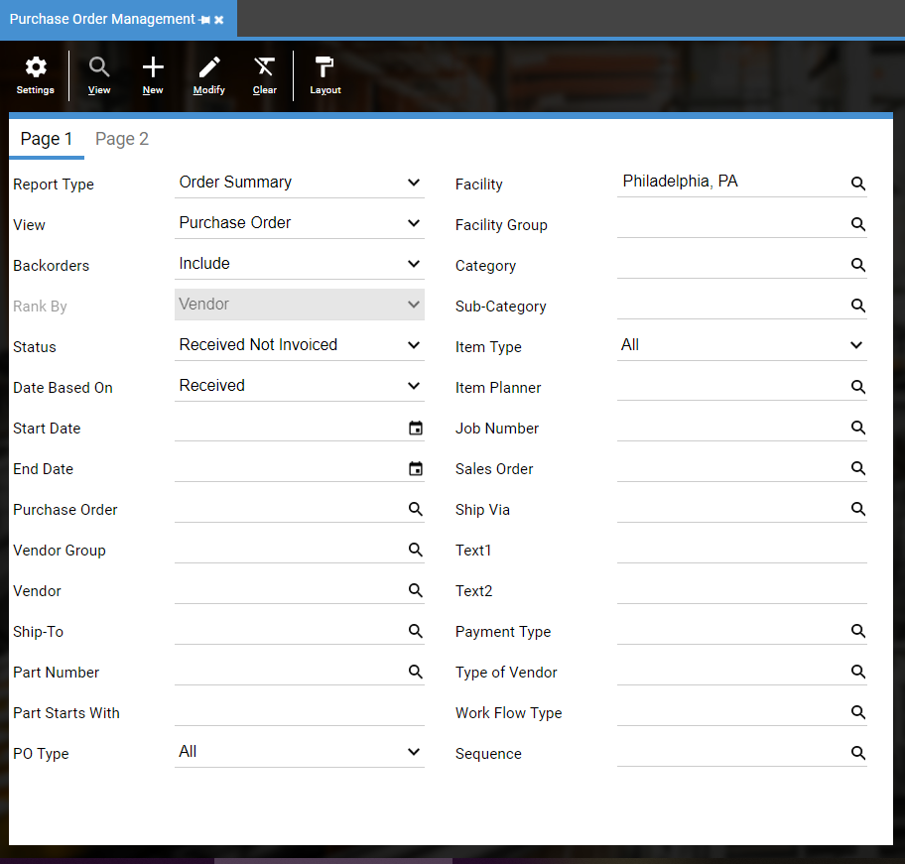

* To see your legacy Purchase Order number, add tp_ref2 to the grid
* Compare to Received Not Invoiced orders report from legacy system

Confirm total number of orders match

Confirm total Amount and Balance match

Confirm individual orders lines for accuracy

* Prior to Actual Go Live, test daily processes using imported data. This typically occurs after a Mock Go Live and/or during a Conference Room Pilot (CRP).

Invoice received Purchase Orders

Total Balance above should match the following report:

* In DEACOM, go to **Accounting** > **Accounting Reporting**
  + **Report Type**: Trial Balance
  + **Date Range**: First Day of Current Fiscal Year to Go Live Date
  + If applicable, run reports by facility, using the Account mask
  + (e.g. ??????-01-??-?? where the second segment is the facility.)
  + Click on **View**

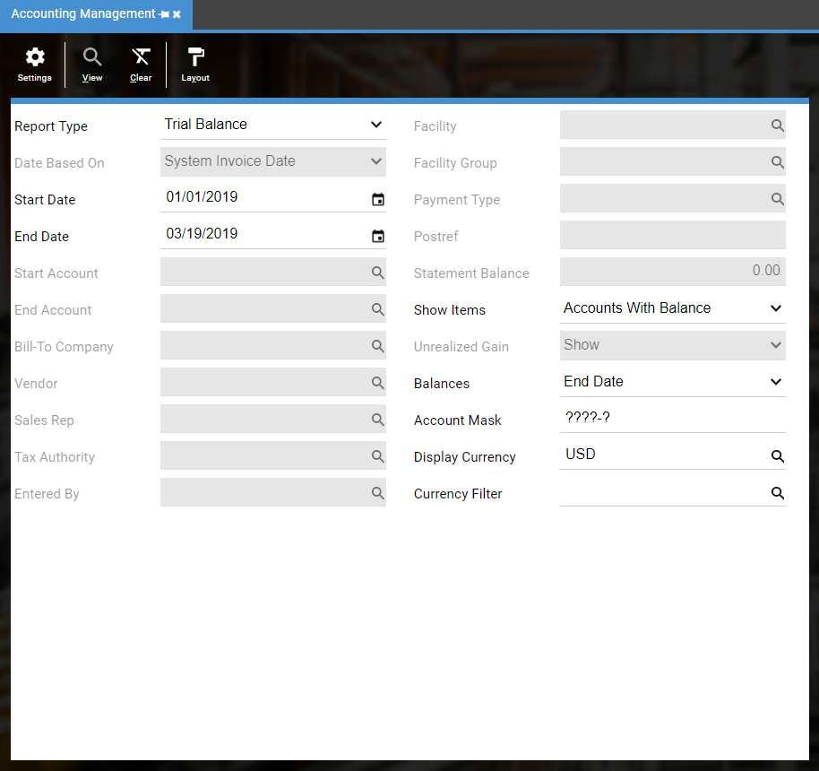

* + Filter by Suspense Account if you have multiple Suspense Account accounts

Confirm that total Suspense Account balance matches the total Order Summary balance above

**Validation of PO – Status: Invoiced**

* In DEACOM, go to **Purchasing > Order Reporting**
* **Report Type**: Order Summary
* **Status**: Invoiced
* Click on **View**

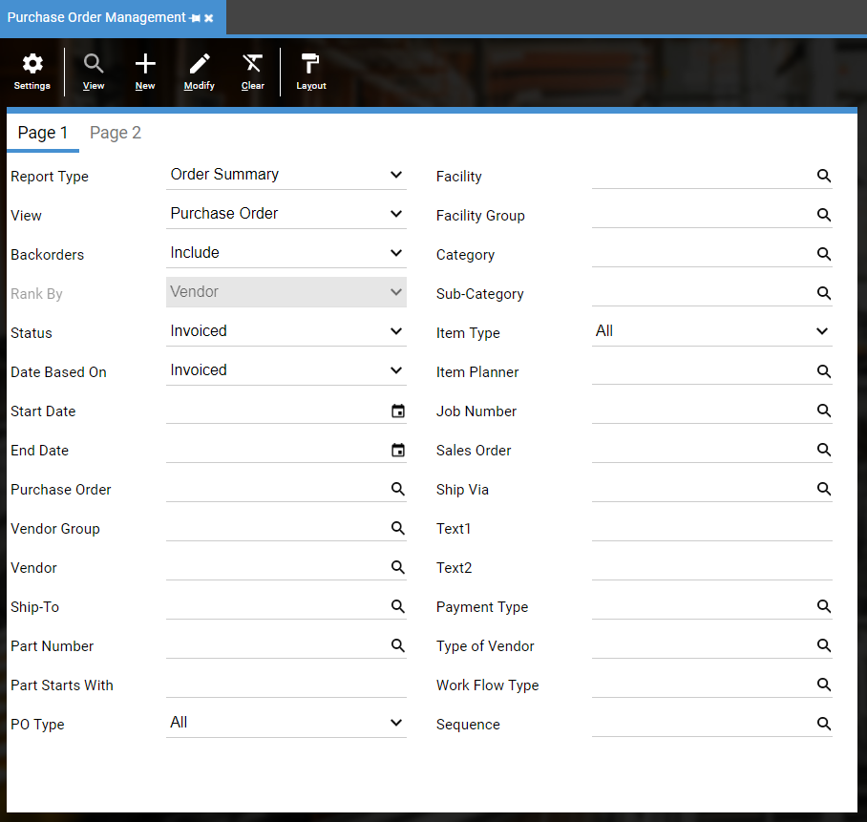

* To see your legacy Invoice number, add tp_ref2 to the grid
* Compare to AP Invoice report from legacy system

Confirm total Amount (not Balance) matches

Confirm individual orders lines for accuracy

Confirm Totals Year by Year. Record total dollars below.

* Record dollars from client’s validation below

|  |  |  |  |
| --- | --- | --- | --- |
| **Company** | **Year** | **Legacy System $** | **DEACOM $ Amount** |
| Company1 |  |  |  |

|  |  |  |  |
| --- | --- | --- | --- |
| **Company** | **Year** | **Legacy System $** | **DEACOM $ Amount** |
| Company2 |  |  |  |

* In DEACOM, go to **Purchasing > Order Reporting**
* **Report Type**: Order Detail
* **Status**: Invoiced
* Click on **View**

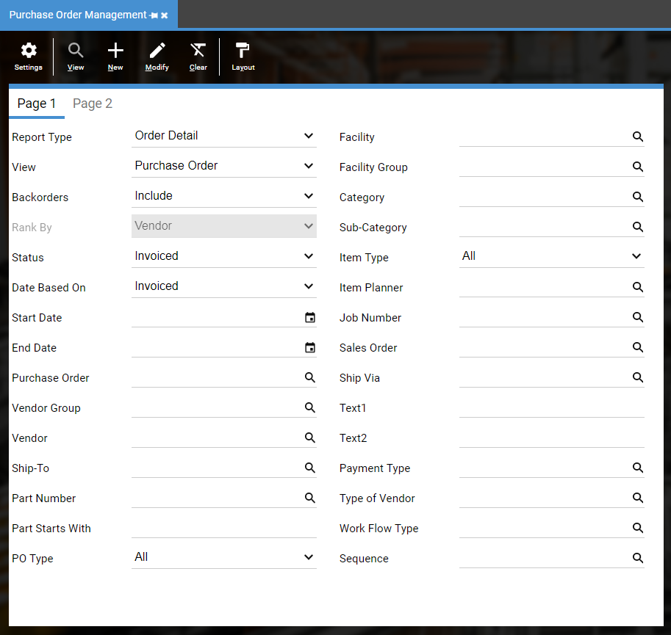

* Compare AP Invoice report from legacy system

Confirm total Amount matches

Confirm individual orders lines for accuracy

**Validation of AP – Set Balances**

* In DEACOM, go to **Purchasing > Order Reporting**
* **Report Type**: Order Summary
* **Status**: Invoiced not paid
* If applicable, run reports by facility
* Click on **View**

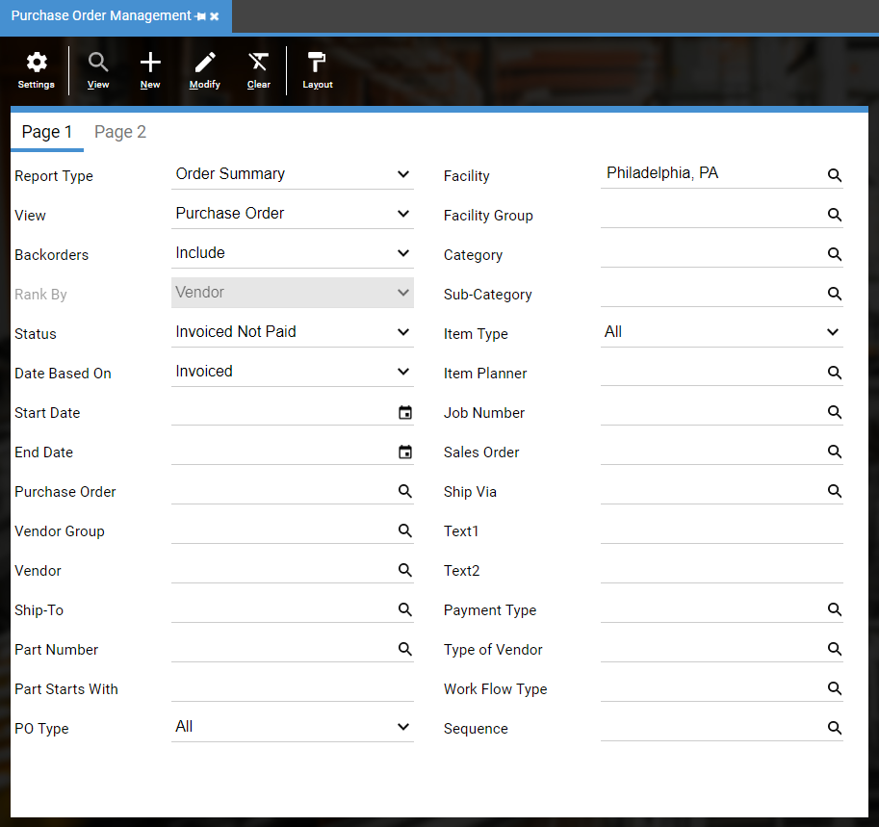

* To see your legacy Invoice number, add tp_ref2 to the grid
* Compare to AP Aging report from legacy system

Confirm and record total Balance (found in the report title bar; not Amount)

Confirm individual orders lines for accuracy

* Use Subtotal button to summarize by Vendor
  + - Click on **More** button
    - Select **Subtotals**
    - Click on **Add**
    - Select **Vendor**
    - **Save** and Close
    - Click the **Summary** button

Confirm vendor Balances (not Amount)

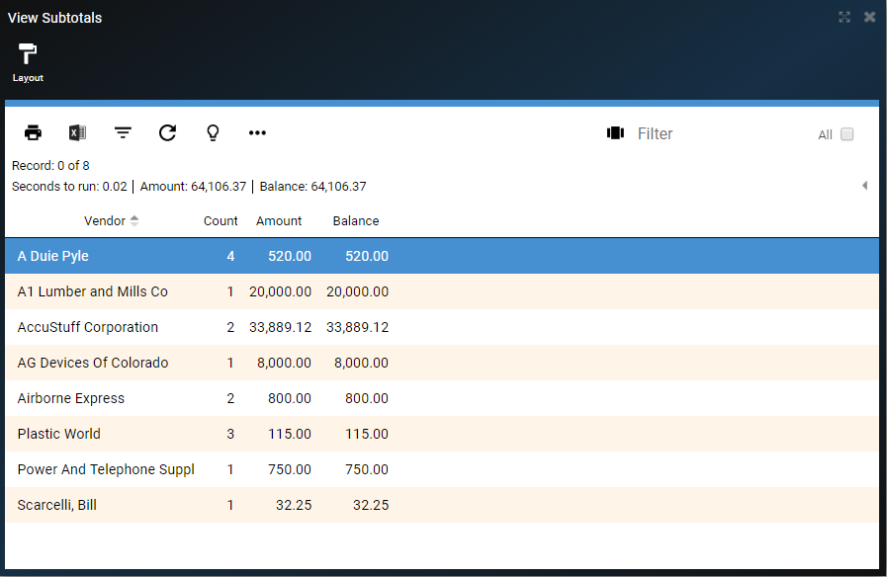

* Prior to Actual Go Live, test daily processes using imported data. This typically occurs after a Mock Go Live and/or during a Conference Room Pilot (CRP).

Do a manual check paying an imported accounts payable

Do a check run paying a group of invoices

Total Balance above should match the following reports:

* In DEACOM, go to **Accounting** > **Accounting Reporting**
* **Report Type**: Trial Balance
* **Date Range**: First Day of Current Fiscal Year to Go Live Date
* If applicable, run reports by facility, using the Account mask
  + (e.g. ??????-01-??-?? where the second segment is the facility.)
* Click on **View**



* Filter by AP Account if you have multiple AP accounts

Confirm that total AP Account balance matches the total Order Summary balance above

* In DEACOM, go to **Accounting** > **Accounting Reporting**
* **Report Type**: Payables summary
* **Date Range**: Use default date
* If applicable, run reports by facility
* Click on **View**

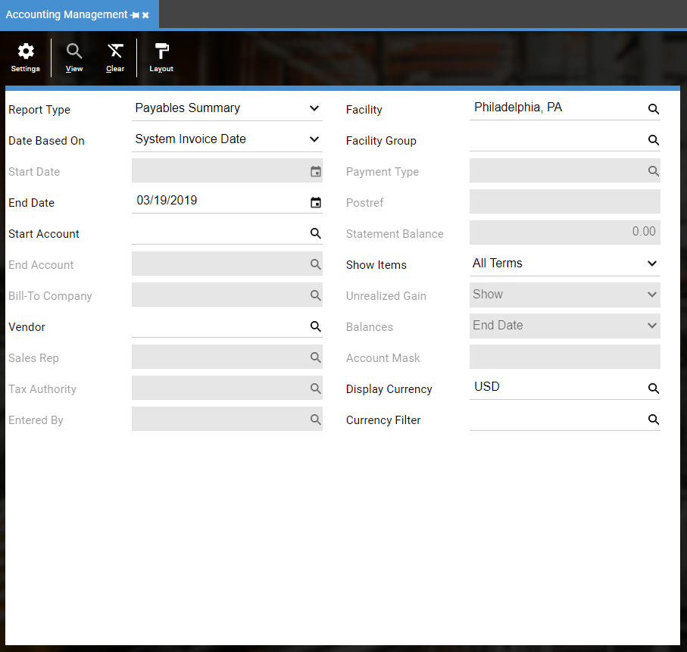

Confirm that total Payables Summary Total Due matches the total balances above

## How

The best way to begin is bring up the unreceived purchase order in the legacy system and bring up the purchase order in DEACOM. Compare all key fields including Due to Dock date, which is required for MRP, to confirm it matches what was imported. Be on the lookout for any missing data. If multiple facilities are imported, run facility reports and confirm the facility is properly set. If using multiple currency, check the currency is set correctly. Be sure to use these orders to perform transactions in DEACOM.

## Roles & Responsibilities

Typically, Subject Matter Experts, Purchasing and Accounting have the responsibility to validate their portion of the data. The Accounting team should confirm the proper AP accounts, expense and inventory accounts are being used. POs received but not invoiced (RNI) and invoices with an open AP balance must match what’s in the GL accounts at go live.

# Data Validation – Full Circle

Below is the full circle for validation.

## Data Imported

Data is imported and validated by the Data Specialists and/or Product Specialist. This validation is a comparison to the load files provided and to confirm the data is going into the correct fields.

## Data Validated

Once imported, it is important for data to be validated by the Subject Matter Experts and/or End Users. This validation is a comparison to the legacy system. Data specialists do not know what is missing if the file never contained the information.

## Data Processed

Once the data is validated, it is time to use the imported data by doing transactions in DEACOM. This ensures the imported data will transact properly with customer specific data. This builds the End Users’ confidence and confidence in DEACOM is higher.

## Postings

Once the data is used in transactions, it is imperative that the general ledger postings are reviewed. That will ensure the configuration of the items, customers, and facilities are posting the dollars to the correct accounts.

## Reports

Once all of the above is completed, run the reports needed to run your business. Are the proper results being captured? All necessary reports should be created and validated before Go Live.

# Why Data Validation Is Critical

When the data has been validated…

## Lower Risks

It has been proven to reduce the risks at Go Live. Less unforeseen issues arise if the data processes have been validated. Practicing with the validated data ensures daily transactions will be able to be completed and lowers overall risks.

## Go Live Duration

It has been proven to reduce the amount of time required for the actual Go Live. If historical data is imported and validated before Go Live, it reduces what needs to be validated during the Go Live. If doing several phases, it will reduce the amount of time Production systems need to be down.

## Customer Service

It will ensure customers will receive accurate orders and invoices. Customer payments can be applied to the correct orders.

## Procurement

It will ensure vendors continue to receive accurate orders and send the material needed for Production. Payments will be sent to the correct Remit to.

## Reporting

Accurate reporting is the result of validation, whether validating imported data or validating manually entered orders. Data that is accurate and usable is crucial to every company to make informed decisions.

## Success

Validated data is the first step to a successful Go Live. The more accurate the data, the quicker the road to success.